1.
Change in https://ratnakanchan.vercel.app/jwellery-retouching
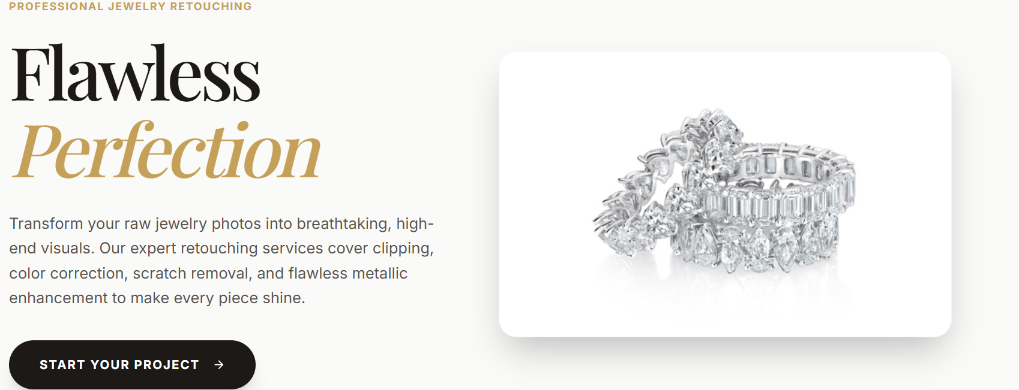
Increase the size of this image in hero section of retouching jewllery.
keep their bottom boundary in level of button of start your project . also crop image show ring more big without cutting ring part.

2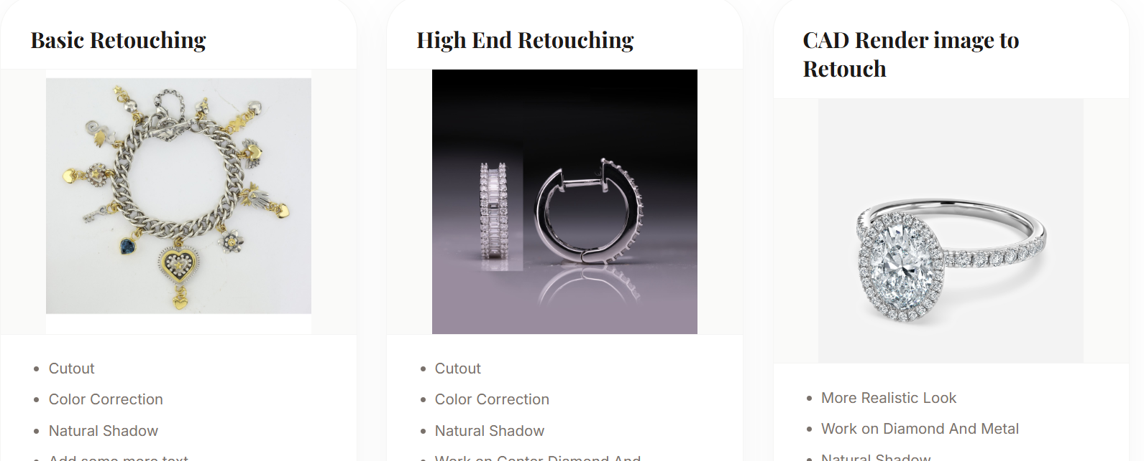
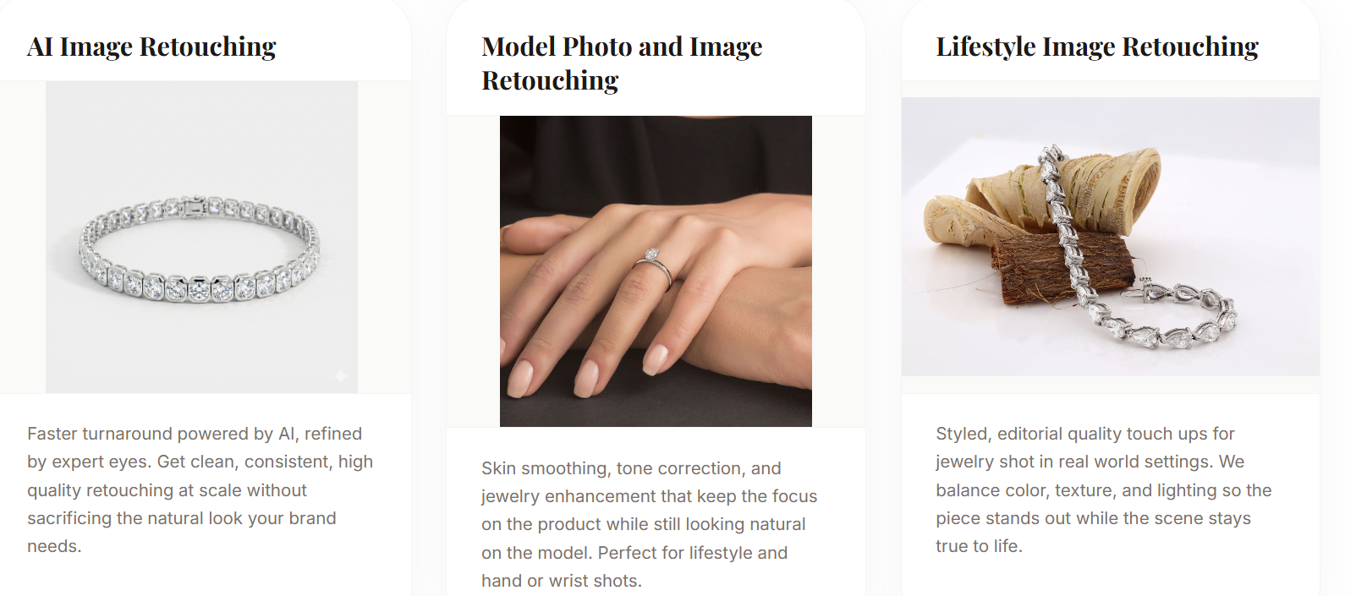

Bring all images properlyin good alighment ,remove warpping of headings of that in retouching page , keep headings in one line properly to keep images properl space nd same allignments .

3
CAD CHANGES
https://ratnakanchan.vercel.app/cad-designing

Change Page name to CAD Designing & Render
Change services Name of CAD Design CAD to Render Image and 360 Animation Rendering
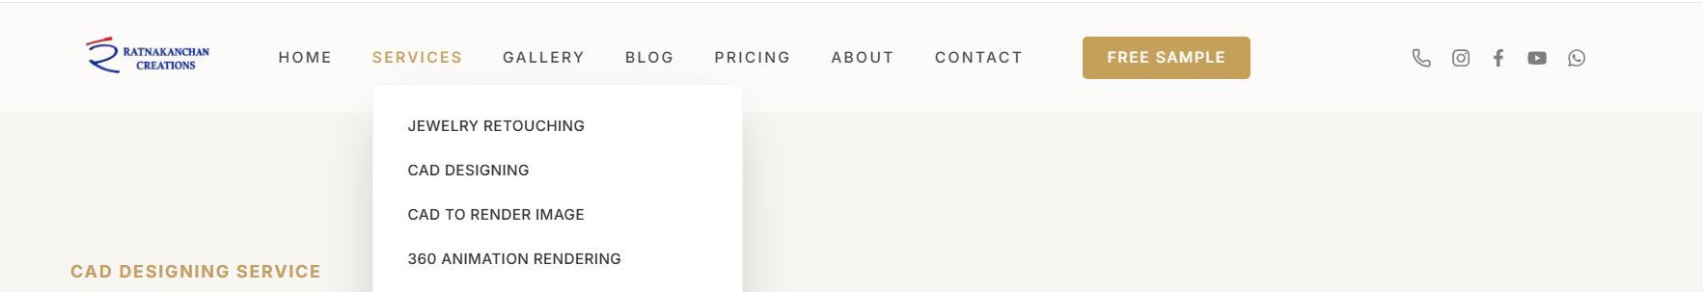

4:
New Page design

OLD page to new page 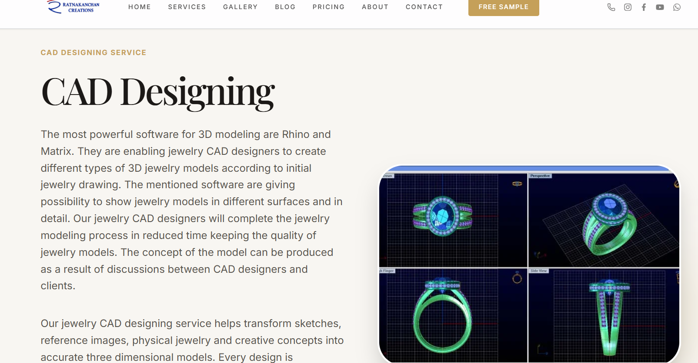

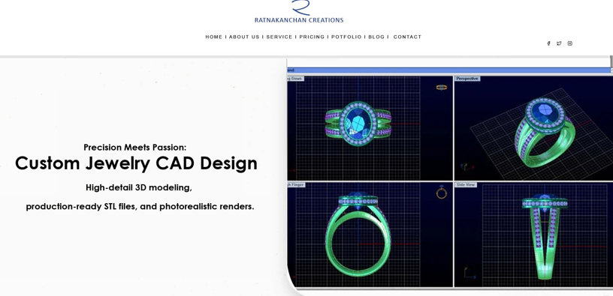
Write this in left side of hero image
Custom Jewelry CAD Design

Turn your jewelry concepts into precise, production-ready 3D CAD models with professional detailing and accurate proportions.

Render Sample

Photorealistic jewelry renders created with realistic metals, diamonds, gemstones, lighting and fine details.

5: Take new images from e drive cad render folder as well as

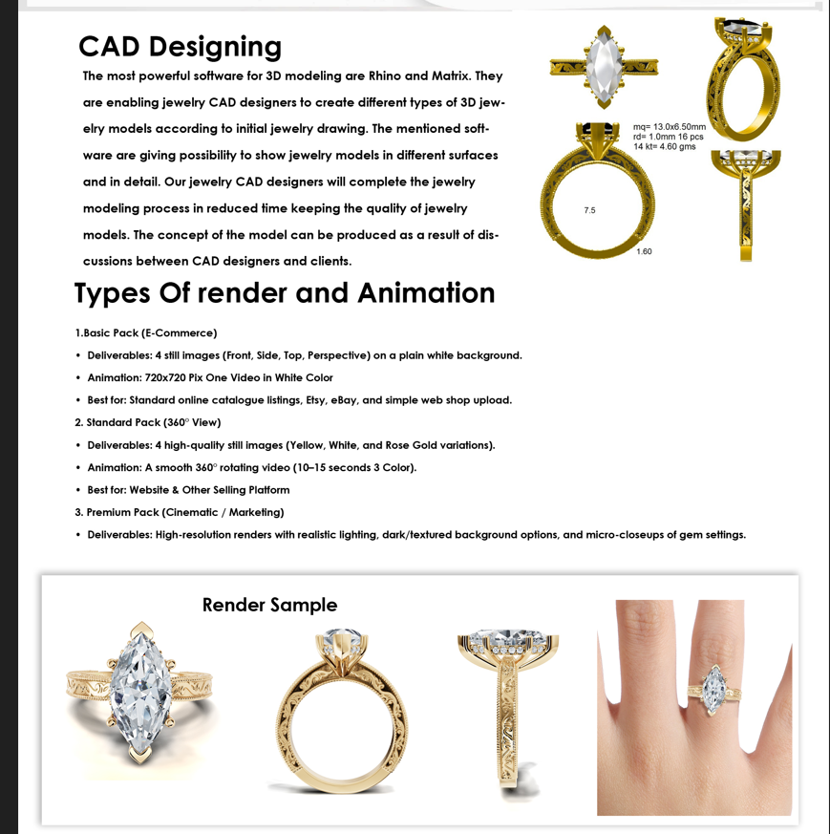
Usage image from e dir cad render folder . see that folder deeply and get images for that page .and also check pagedesign.jpeg for getting page design idea .
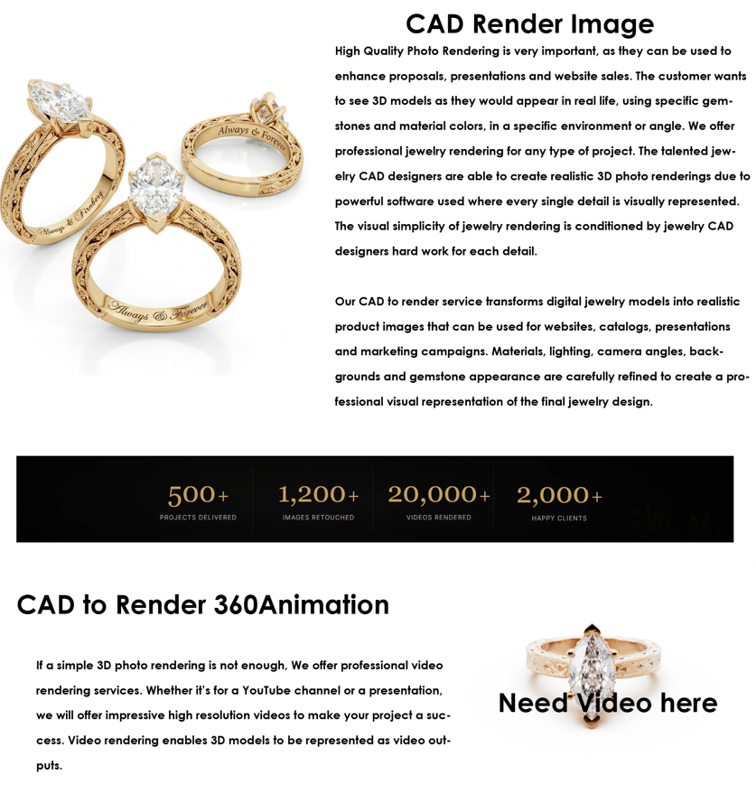

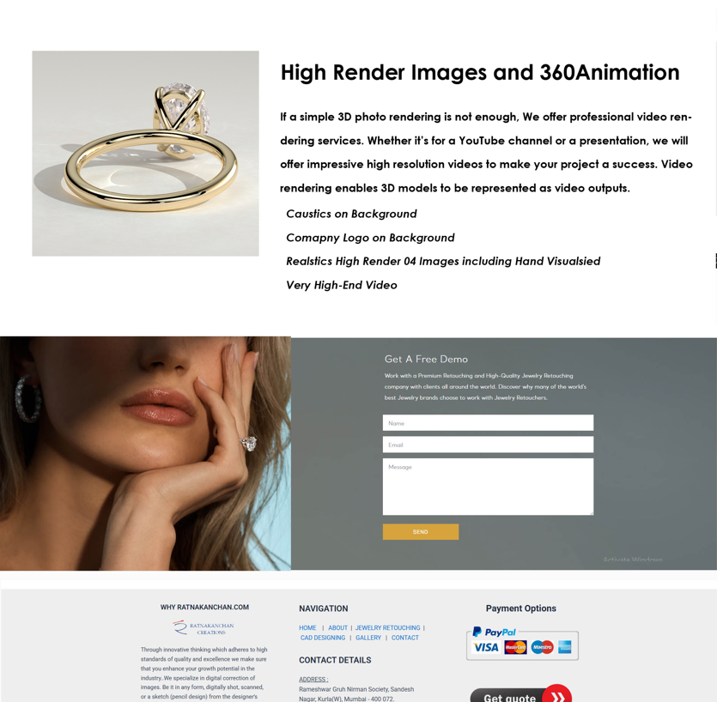

Check images get data drom e drive of images and content from images for cad service vala page.
2. Ask if ny doubt and do all work properly .
3. Remove extra code make app light and also remove extra images files present on ratnakanchan.
4. Do everything properly in steps

